VICTOR HARBOR 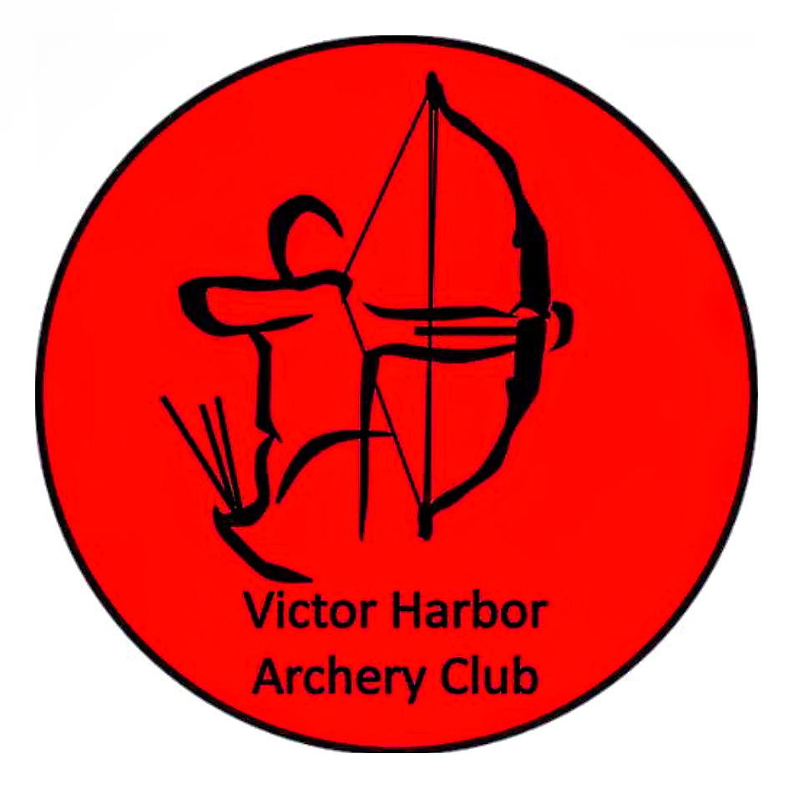ARCHERY CLUB
Postal Address: PO Box 2184 Victor Harbor SA 5211 Phone: Course Coordinator Paul Bagnell: 0417891814

BEGINNERS COURSE BOOKING FORM

VHAC welcomes anyone with an interest in Archery to attend our Beginners Course.
There are no special requirements – all genders and ages may apply.

For full details of course costs and conditions, please refer to our website: www.victorharborarcheryclub.com

COST OF COURSE: $160 per person for 4 hours tuition.
$40 in line fee credits redeemable in the first month of becoming a full member.
Full payment of course is required at time of booking.

This course is held at the VHAC grounds, 49 Back Valley Rd, Lower Inman Valley.
Course time: Saturdays 12noon to 4pm.

Please note: In signing up for this course as a temporary member, you are giving permission for VHAC to use your name and take digital images of you for VHAC publicity purposes as deemed necessary by the club.

NAME of Person/s attending course [please print]:

1. __________________________________________ 2. _________________________________________ 3. ___________________________________________

Postal Address: _______________________________________________________________________________________________________________________

Phone No’s: Home:________________________________ Mobile:________________________________

Email Address: ________________________________________________________

To confirm your booking, please complete the Beginners Course Booking Form and complete payment of $160 via direct bank deposit [information below]
Email the completed form to Course Coordinator Paul Bagnell at: paul.bagnell@hotmail.com

A form returned without payment will not be accepted.

A confirmation of your booking and payment will be sent to you before the course is due to start. Please contact VHAC if this is not received. If you are unable to attend your course, please notify VHAC ASAP.

Parent or guardian must accompany all children under the age of 16 years at all times.

To pay via direct bank deposit, the VHAC bank account details are:

BSB: 015 716 Account No: 283570184 Account Name: Victor Harbor Archery Club

Please include a description of payment e.g.: beginners course/your surname [beginners course/smith]

Course dates and fees may be altered without notice.

Club use only: Course date: _______________ Form received by_________________________________________Date:_______________

Payment received: ____________________ Receipt No: ____________

VHAC beginner course 2023

